Einsendeaufgabe 1

*Entwurf*

a) Ein Mealy-Automat hat 4 Zustände und ein Moore-Automat hat 5 Zustände

b) **Zustandsdiagramm: Moore**

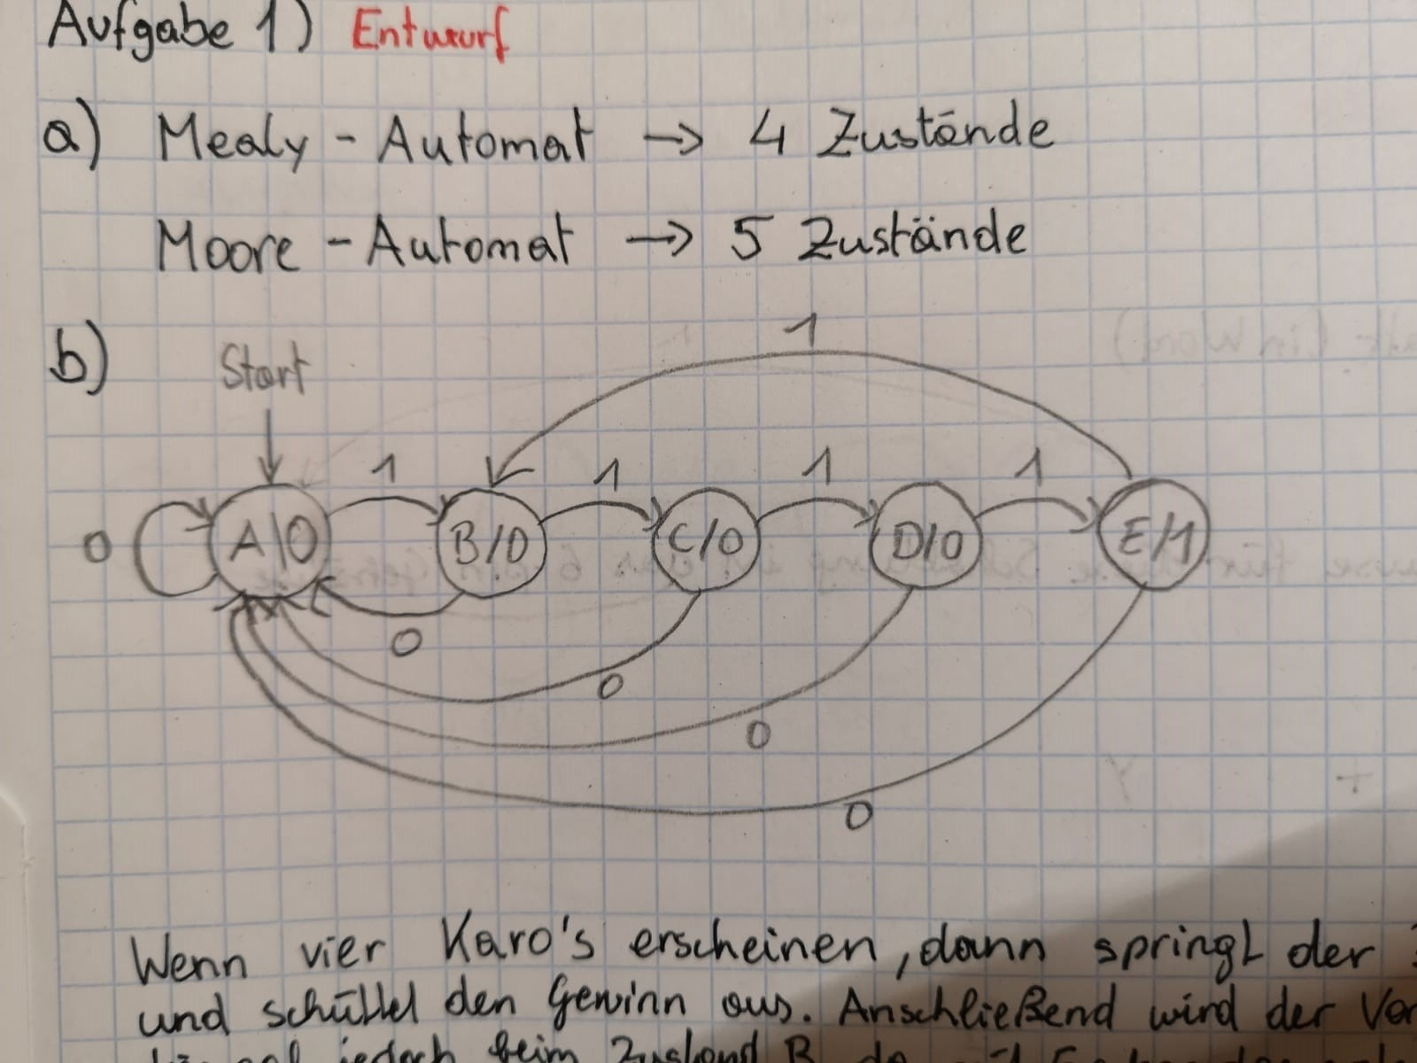

Es gibt insgesamt 5 Zustände in diesem Automaten. Jedes Mal, wenn der Hebel des Automaten betätigt wird und dabei ein Karo erscheint, springt der Automat zum nächsten Zustand. Dabei passiert das vier Mal, da nach dem vierten Mal der Zustand E erreicht wird und der Gewinn anschließend ausgegeben wird. Sollte jedoch dazwischen einmal ein anderes Symbol (Herz, Pick, Kreuz) als das Karo erscheinen, dann springt der Automat wieder zum Zustand A.

c) **Zustandstabelle**

|  |  |  |  |
| --- | --- | --- | --- |
| S | x | S‘ | y |
| A | 0 | A | 0 |
| A | 1 | B | 0 |
| B | 0 | A | 0 |
| B | 1 | C | 0 |
| C | 0 | A | 0 |
| C | 1 | D | 0 |
| D | 0 | A | 0 |
| D | 1 | E | 0 |
| E | 0 | A | 1 |
| E | 1 | B | 1 |

*Realisierung*

d) Binärcodierung Q ⊆ {0, 1} k

e)   
**Ausgabetabelle:**

|  |  |  |  |
| --- | --- | --- | --- |
| q2 | q1 | q0 | y |
| 0 | 0 | 0 | 0 |
| 0 | 0 | 1 | 0 |
| 0 | 1 | 0 | 0 |
| 0 | 1 | 1 | 0 |
| 1 | 0 | 0 | 1 |

|  |  |  |  |  |  |  |  |  |  |  |  |  |  |
| --- | --- | --- | --- | --- | --- | --- | --- | --- | --- | --- | --- | --- | --- |
| q2 | q1 | q0 | x | q2‘ | q1‘ | q0‘ | J2 | K2 | J1 | K1 | J0 | K0 | y |
| 0 | 0 | 0 | 0 | 0 | 0 | 0 | 0 | d | 0 | d | 0 | d | 0 |
| 0 | 0 | 0 | 1 | 0 | 0 | 1 | 0 | d | 0 | d | 1 | d | 0 |
| 0 | 0 | 1 | 0 | 0 | 0 | 0 | 0 | d | 0 | d | d | 1 | 0 |
| 0 | 0 | 1 | 1 | 0 | 1 | 0 | 0 | d | 1 | d | d | 1 | 0 |
| 0 | 1 | 0 | 0 | 0 | 0 | 0 | 0 | d | d | 1 | 0 | d | 0 |
| 0 | 1 | 0 | 1 | 0 | 1 | 1 | 0 | d | d | 0 | 1 | d | 0 |
| 0 | 1 | 1 | 0 | 0 | 0 | 0 | 0 | d | d | 1 | d | 1 | 0 |
| 0 | 1 | 1 | 1 | 1 | 0 | 0 | 1 | d | d | 1 | d | 1 | 0 |
| 1 | 0 | 0 | 0 | 0 | 0 | 0 | D | 1 | 0 | d | 0 | d | 1 |
| 1 | 0 | 0 | 1 | 0 | 0 | 1 | D | 1 | 0 | d | 1 | d | 1 |

**Ansteuerungstabelle:**

f)   
  
**Ausgabegleichung (minimiert): $$y=q_{2}\overline{q_{1}}\overline{q_{0}}$$**

**Ansteuerungsgleichung (minimiert):**   
J2 :

|  |  |  |  |  |  |  |  |  |  |  |  |  |  |  |  |  |  |  |  |  |  |  |
| --- | --- | --- | --- | --- | --- | --- | --- | --- | --- | --- | --- | --- | --- | --- | --- | --- | --- | --- | --- | --- | --- | --- |
|  |  |  |  |  |  |  | Q1 | | |  | |  |  | |  | |  | |  | |  | |
|  |  |  |  |  |  |  |  |  | |  | |  |  | |  | |  | |  | |  | |
|  |  | 0000 |  |  | 0100 |  |  | 1100 | |  | |  | 1000 | |  | |  | |  | |  | |
|  |  |  | 0 |  |  | 0 |  |  | | d | |  |  | | d | |  | |  | |  | |
|  |  |  |  |  |  |  |  |  | |  | |  |  | |  | |  | |  | |  | |
|  |  | 0010 |  |  | 0110 |  |  | 1110 | |  | |  | 1010 | |  | |  | |  | |
|  |  |  | 0 |  |  | 0 |  |  | | d | |  |  | | d | |  | |  | |  | |
| Q0 |  |  |  |  |  |  |  |  | |  | |  |  | |  | |  | |  | |  | |
|  | 0011 |  |  | 0111 | |  | 1111 | | | |  | 1011 | | | |  | |  | |
|  |  |  | 0 |  |  | 1 |  |  | | d | |  |  | | d | |  | |  | |  | |
|  |  |  |  |  |  |  |  |  | |  | |  |  | |  | |  | |  | | X | |
|  |  | 0001 |  |  | 0101 | |  | 1101 | | | |  | 1001 | | | |  | |  | |
|  |  |  | 0 |  |  | 0 |  |  | | d | |  |  | | d | |  | |  | |  | |
|  |  |  |  |  |  |  |  |  | |  | |  |  | |  | |  | |  | |  | |
|  |  |  |  |  |  |  |  |  | |  | |  |  | |  | |  | |  | |  | |
|  |  |  |  |  | |  |  |  |  | | Q2 | | |  | |  | |  | |  | |
|  |  |  |  |  |  |  |  |  | |  | |  |  | |  | |  | |  | |  | |

|  |  |  |  |  |  |  |  |  |  |  |  |  |  |  |  |  |  |  |  |  |  |  |
| --- | --- | --- | --- | --- | --- | --- | --- | --- | --- | --- | --- | --- | --- | --- | --- | --- | --- | --- | --- | --- | --- | --- |
|  |  |  |  |  |  |  | Q1 | | |  | |  |  | |  | |  | |  | |  | |
|  |  |  |  |  |  |  |  |  | |  | |  |  | |  | |  | |  | |  | |
|  |  | 0000 |  |  | 0100 |  |  | 1100 | |  | |  | 1000 | |  | |  | |  | |  | |
|  |  |  | d |  |  | d |  |  | | d | |  |  | | 1 | |  | |  | |  | |
|  |  |  |  |  |  |  |  |  | |  | |  |  | |  | |  | |  | |  | |
|  |  | 0010 |  |  | 0110 |  |  | 1110 | |  | |  | 1010 | |  | |  | |  | |
|  |  |  | d |  |  | d |  |  | | d | |  |  | | d | |  | |  | |  | |
| Q0 |  |  |  |  |  |  |  |  | |  | |  |  | |  | |  | |  | |  | |
|  | 0011 |  |  | 0111 | |  | 1111 | | | |  | 1011 | | | |  | |  | |
|  |  |  | d |  |  | d |  |  | | d | |  |  | | d | |  | |  | |  | |
|  |  |  |  |  |  |  |  |  | |  | |  |  | |  | |  | |  | | X | |
|  |  | 0001 |  |  | 0101 | |  | 1101 | | | |  | 1001 | | | |  | |  | |
|  |  |  | d |  |  | d |  |  | | d | |  |  | | 1 | |  | |  | |  | |
|  |  |  |  |  |  |  |  |  | |  | |  |  | |  | |  | |  | |  | |
|  |  |  |  |  |  |  |  |  | |  | |  |  | |  | |  | |  | |  | |
|  |  |  |  |  | |  |  |  |  | | Q2 | | |  | |  | |  | |  | |
|  |  |  |  |  |  |  |  |  | |  | |  |  | |  | |  | |  | |  | |

K2 :

J1 :

|  |  |  |  |  |  |  |  |  |  |  |  |  |  |  |  |  |  |  |  |  |  |  |
| --- | --- | --- | --- | --- | --- | --- | --- | --- | --- | --- | --- | --- | --- | --- | --- | --- | --- | --- | --- | --- | --- | --- |
|  |  |  |  |  |  |  | Q1 | | |  | |  |  | |  | |  | |  | |  | |
|  |  |  |  |  |  |  |  |  | |  | |  |  | |  | |  | |  | |  | |
|  |  | 0000 |  |  | 0100 |  |  | 1100 | |  | |  | 1000 | |  | |  | |  | |  | |
|  |  |  | 0 |  |  | d |  |  | | d | |  |  | | 0 | |  | |  | |  | |
|  |  |  |  |  |  |  |  |  | |  | |  |  | |  | |  | |  | |  | |
|  |  | 0010 |  |  | 0110 |  |  | 1110 | |  | |  | 1010 | |  | |  | |  | |
|  |  |  | 0 |  |  | d |  |  | | d | |  |  | | d | |  | |  | |  | |
| Q0 |  |  |  |  |  |  |  |  | |  | |  |  | |  | |  | |  | |  | |
|  | 0011 |  |  | 0111 | |  | 1111 | | | |  | 1011 | | | |  | |  | |
|  |  |  | 1 |  |  | d |  |  | | d | |  |  | | d | |  | |  | |  | |
|  |  |  |  |  |  |  |  |  | |  | |  |  | |  | |  | |  | | X | |
|  |  | 0001 |  |  | 0101 | |  | 1101 | | | |  | 1001 | | | |  | |  | |
|  |  |  | 0 |  |  | d |  |  | | d | |  |  | | 0 | |  | |  | |  | |
|  |  |  |  |  |  |  |  |  | |  | |  |  | |  | |  | |  | |  | |
|  |  |  |  |  |  |  |  |  | |  | |  |  | |  | |  | |  | |  | |
|  |  |  |  |  | |  |  |  |  | | Q2 | | |  | |  | |  | |  | |
|  |  |  |  |  |  |  |  |  | |  | |  |  | |  | |  | |  | |  | |

K1 :

|  |  |  |  |  |  |  |  |  |  |  |  |  |  |  |  |  |  |  |  |  |  |  |
| --- | --- | --- | --- | --- | --- | --- | --- | --- | --- | --- | --- | --- | --- | --- | --- | --- | --- | --- | --- | --- | --- | --- |
|  |  |  |  |  |  |  | Q1 | | |  | |  |  | |  | |  | |  | |  | |
|  |  |  |  |  |  |  |  |  | |  | |  |  | |  | |  | |  | |  | |
|  |  | 0000 |  |  | 0100 |  |  | 1100 | |  | |  | 1000 | |  | |  | |  | |  | |
|  |  |  | d |  |  | 1 |  |  | | d | |  |  | | d | |  | |  | |  | |
|  |  |  |  |  |  |  |  |  | |  | |  |  | |  | |  | |  | |  | |
|  |  | 0010 |  |  | 0110 |  |  | 1110 | |  | |  | 1010 | |  | |  | |  | |
|  |  |  | d |  |  | 1 |  |  | | d | |  |  | | d | |  | |  | |  | |
| Q0 |  |  |  |  |  |  |  |  | |  | |  |  | |  | |  | |  | |  | |
|  | 0011 |  |  | 0111 | |  | 1111 | | | |  | 1011 | | | |  | |  | |
|  |  |  | d |  |  | 1 |  |  | | d | |  |  | | d | |  | |  | |  | |
|  |  |  |  |  |  |  |  |  | |  | |  |  | |  | |  | |  | | X | |
|  |  | 0001 |  |  | 0101 | |  | 1101 | | | |  | 1001 | | | |  | |  | |
|  |  |  | d |  |  | 0 |  |  | | d | |  |  | | d | |  | |  | |  | |
|  |  |  |  |  |  |  |  |  | |  | |  |  | |  | |  | |  | |  | |
|  |  |  |  |  |  |  |  |  | |  | |  |  | |  | |  | |  | |  | |
|  |  |  |  |  | |  |  |  |  | | Q2 | | |  | |  | |  | |  | |
|  |  |  |  |  |  |  |  |  | |  | |  |  | |  | |  | |  | |  | |

J0 :

|  |  |  |  |  |  |  |  |  |  |  |  |  |  |  |  |  |  |  |  |  |  |  |
| --- | --- | --- | --- | --- | --- | --- | --- | --- | --- | --- | --- | --- | --- | --- | --- | --- | --- | --- | --- | --- | --- | --- |
|  |  |  |  |  |  |  | Q1 | | |  | |  |  | |  | |  | |  | |  | |
|  |  |  |  |  |  |  |  |  | |  | |  |  | |  | |  | |  | |  | |
|  |  | 0000 |  |  | 0100 |  |  | 1100 | |  | |  | 1000 | |  | |  | |  | |  | |
|  |  |  | 0 |  |  | 0 |  |  | | d | |  |  | | 0 | |  | |  | |  | |
|  |  |  |  |  |  |  |  |  | |  | |  |  | |  | |  | |  | |  | |
|  |  | 0010 |  |  | 0110 |  |  | 1110 | |  | |  | 1010 | |  | |  | |  | |
|  |  |  | d |  |  | d |  |  | | d | |  |  | | d | |  | |  | |  | |
| Q0 |  |  |  |  |  |  |  |  | |  | |  |  | |  | |  | |  | |  | |
|  | 0011 |  |  | 0111 | |  | 1111 | | | |  | 1011 | | | |  | |  | |
|  |  |  | d |  |  | d |  |  | | d | |  |  | | d | |  | |  | |  | |
|  |  |  |  |  |  |  |  |  | |  | |  |  | |  | |  | |  | | X | |
|  |  | 0001 |  |  | 0101 | |  | 1101 | | | |  | 1001 | | | |  | |  | |
|  |  |  | 1 |  |  | 1 |  |  | | d | |  |  | | 1 | |  | |  | |  | |
|  |  |  |  |  |  |  |  |  | |  | |  |  | |  | |  | |  | |  | |
|  |  |  |  |  |  |  |  |  | |  | |  |  | |  | |  | |  | |  | |
|  |  |  |  |  | |  |  |  |  | | Q2 | | |  | |  | |  | |  | |
|  |  |  |  |  |  |  |  |  | |  | |  |  | |  | |  | |  | |  | |

K0 :

|  |  |  |  |  |  |  |  |  |  |  |  |  |  |  |  |  |  |  |  |  |  |  |
| --- | --- | --- | --- | --- | --- | --- | --- | --- | --- | --- | --- | --- | --- | --- | --- | --- | --- | --- | --- | --- | --- | --- |
|  |  |  |  |  |  |  | Q1 | | |  | |  |  | |  | |  | |  | |  | |
|  |  |  |  |  |  |  |  |  | |  | |  |  | |  | |  | |  | |  | |
|  |  | 0000 |  |  | 0100 |  |  | 1100 | |  | |  | 1000 | |  | |  | |  | |  | |
|  |  |  | d |  |  | d |  |  | | d | |  |  | | d | |  | |  | |  | |
|  |  |  |  |  |  |  |  |  | |  | |  |  | |  | |  | |  | |  | |
|  |  | 0010 |  |  | 0110 |  |  | 1110 | |  | |  | 1010 | |  | |  | |  | |
|  |  |  | 1 |  |  | 1 |  |  | | d | |  |  | | d | |  | |  | |  | |
| Q0 |  |  |  |  |  |  |  |  | |  | |  |  | |  | |  | |  | |  | |
|  | 0011 |  |  | 0111 | |  | 1111 | | | |  | 1011 | | | |  | |  | |
|  |  |  | 1 |  |  | 1 |  |  | | d | |  |  | | d | |  | |  | |  | |
|  |  |  |  |  |  |  |  |  | |  | |  |  | |  | |  | |  | | X | |
|  |  | 0001 |  |  | 0101 | |  | 1101 | | | |  | 1001 | | | |  | |  | |
|  |  |  | d |  |  | d |  |  | | d | |  |  | | d | |  | |  | |  | |
|  |  |  |  |  |  |  |  |  | |  | |  |  | |  | |  | |  | |  | |
|  |  |  |  |  |  |  |  |  | |  | |  |  | |  | |  | |  | |  | |
|  |  |  |  |  | |  |  |  |  | | Q2 | | |  | |  | |  | |  | |
|  |  |  |  |  |  |  |  |  | |  | |  |  | |  | |  | |  | |  | |

g)

J2 :

K2 :

J1 :

K1 :

J0 :

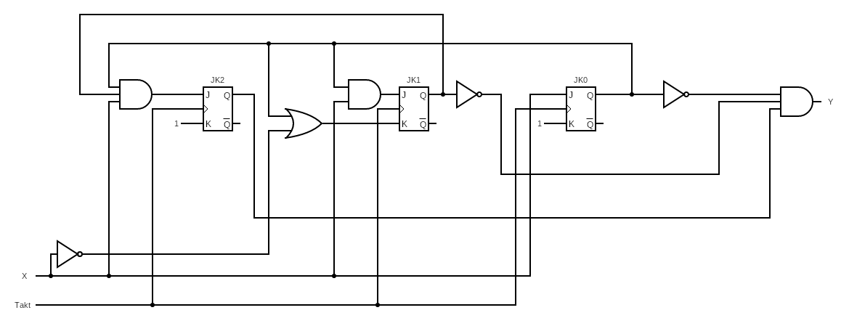K0 :

*Verpackung*

h) Für meinen Zustandsautomaten, wähle ich das Gehäuse mit den 6-Pins

i)

Ein Bild, das Platz enthält.



|  |  |  |
| --- | --- | --- |
| Pin.Nr.: | Beschriftung | Funktion |
| 1 | X | Signaleingang |
| 2 | T | Takteingang |
| 3 |  | Erde (Ground) |
| 4 | y | Signalausgabe |
| 5 | - | unbesetzt |
| 6 | + | Spannungseingang |



j)   
Pin Nr. 1 ist für den Signaleingang besetzt, d.h. wenn der Hebel des Automaten betätigt wird, kommt ein Signal in diesen Pin und das erste Symbol wird generiert.

Pin Nr.2 bekommt mit dem Eingang ein Signal, Pin 2 sorgt dafür das alle Komponenten des Schaltwerks synchron laufen und es nicht zu unerwünschten Verzögerungen kommt.

Pin Nr.3 ist für Erde/Ground reserviert, dieser gibt das Nullpotential an und dient als Referenzwert von 0V.

Pin Nr.4 ist mit der Funktion der Gewinnausgabe versehen. Hier wird ein Signal ausgegeben sobald auf dem Automaten vier Mal Karo erscheint dieses Signal sorgt dafür das der gewinn ausgeschüttet wird.

Pin Nr.5 ist unbelegt.

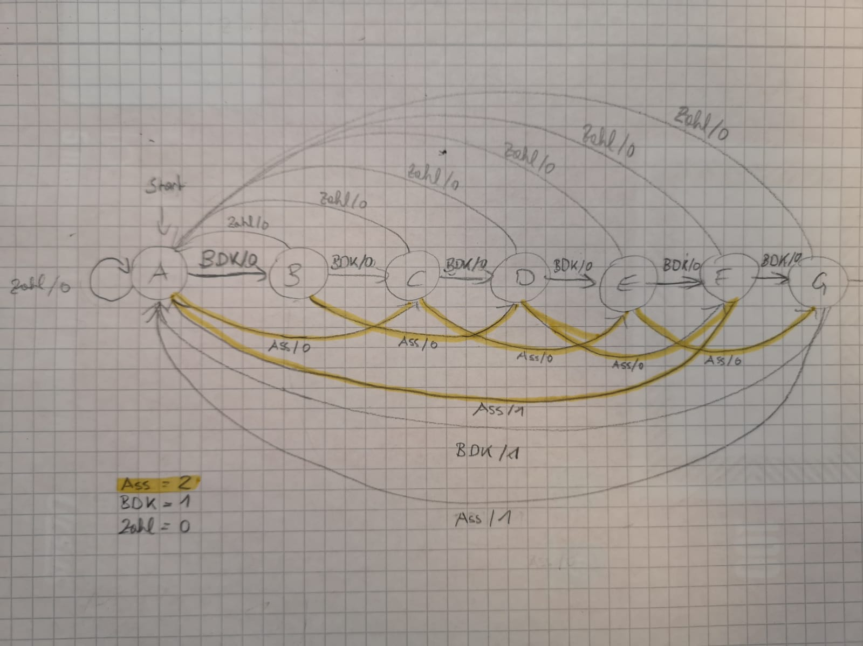Pin Nr.6 ist für den Spannungseingang von 5 V besetzt.

*Version 2*

k)

l)   
Spalten: $$q_{2}{ | q}_{1} |{ q}_{0} \left|x \right| q_{2}'{ | q}_{1}' |{ q}_{0}' | J_{2}{ {| K}_{2} | J}_{1} {| K}_{1}|{ J}_{0} \left|{ K}_{0} \right| y$$ Zeilen: $$7\left(Zustände\right)*3\left(mögliche Eingänge pro Zustand\right)=21 Zeilen$$